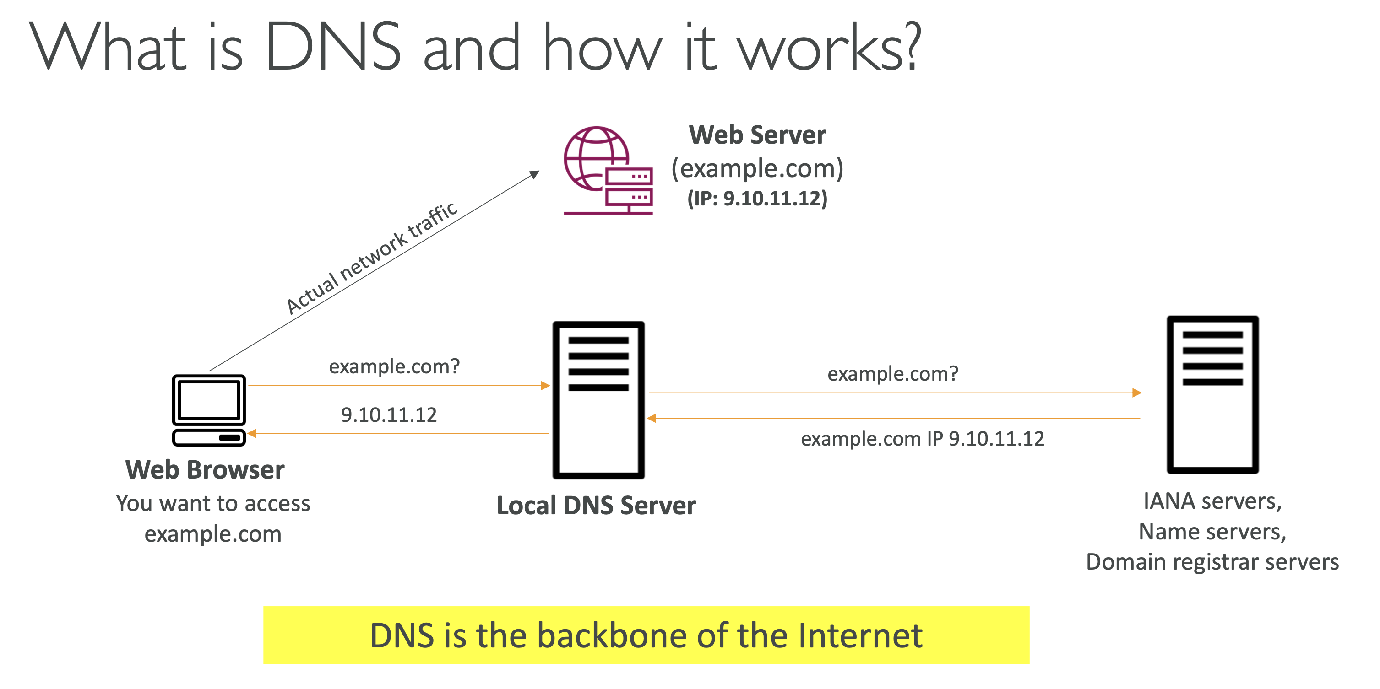

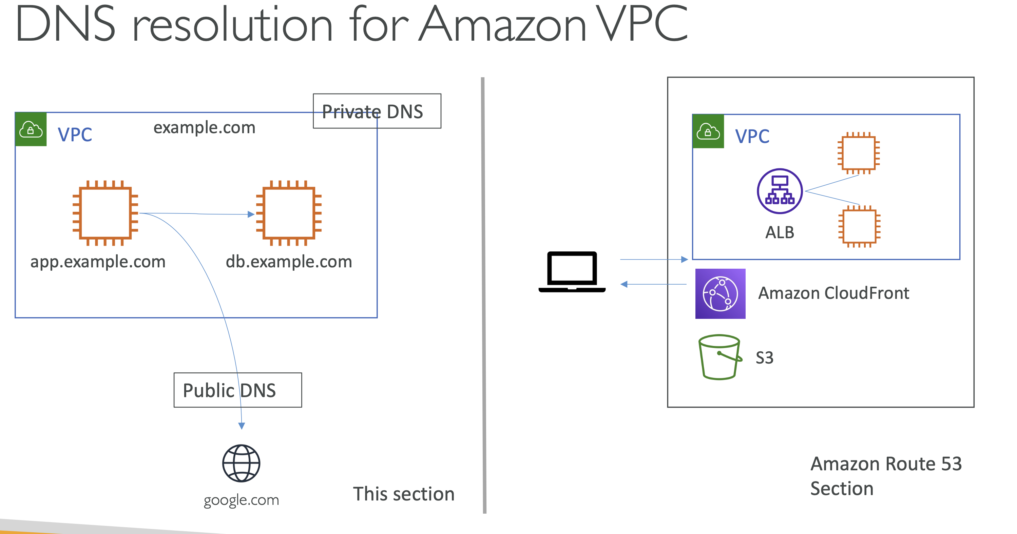

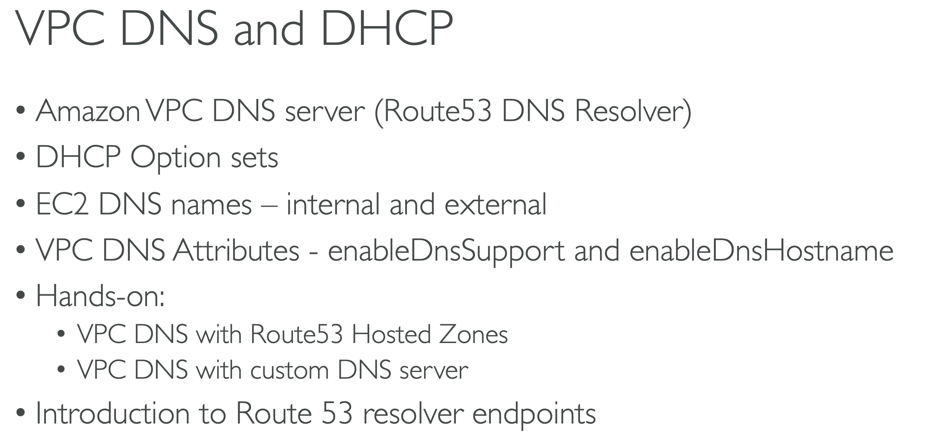

Amazon VPC DNS server, Route53 DNS Resolver are different names for the same thing.

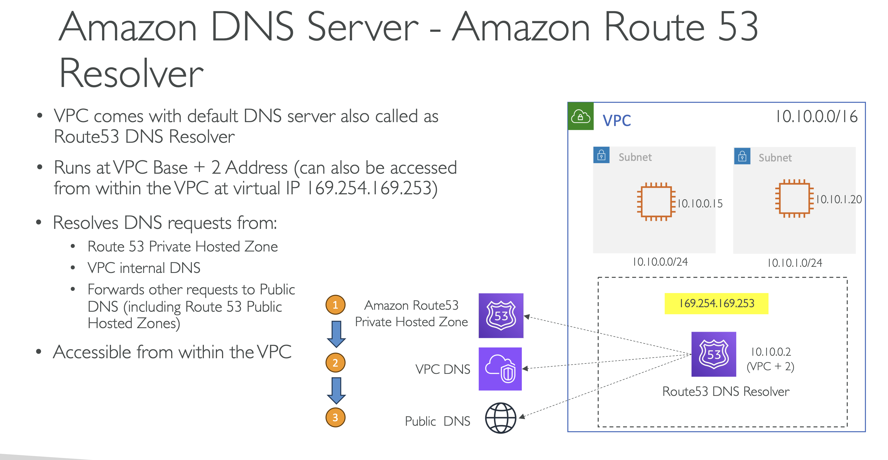

So there is a VPC, there are subnets and then EC2 instances.

Now if any of these EC2 instance has to resolve some DNS for say google.com or other, if you have multiple machines within the same VPC and you want to access that machine over the DNS rather than IP address, then how that happens.

Now, whenever you create a VPC, AWS will also create something called a default DNS server for that VPC and this DNS server sits within the VPC.

But the question is on which IP address does it run?

So we have talked about this briefly in the earlier session.

But your route 53 DNS resolver runs on the VPC base address plus two.

So if your VPC IPv4 cider is 10.1.0.0, then this DNS resolver will run at 10.1.0.2.

And it can also be accessed over a virtual IP that is 169.254.169.253, but note that this IP address is only accessible from within the VPC, right?

So VPC base address plus two as well as this virtual IP.

Now what is the role of this DNS resolver.

Of course role is to resolve the DNS queries from the EC2 instances.

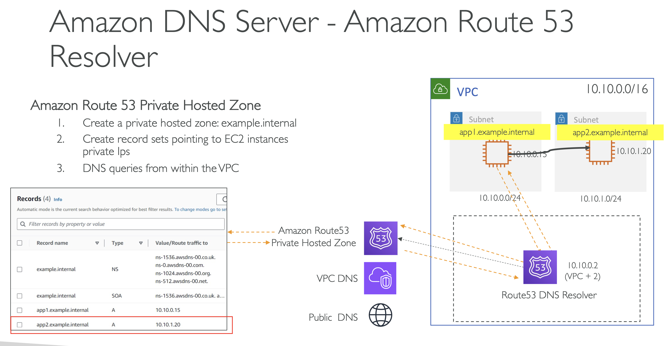

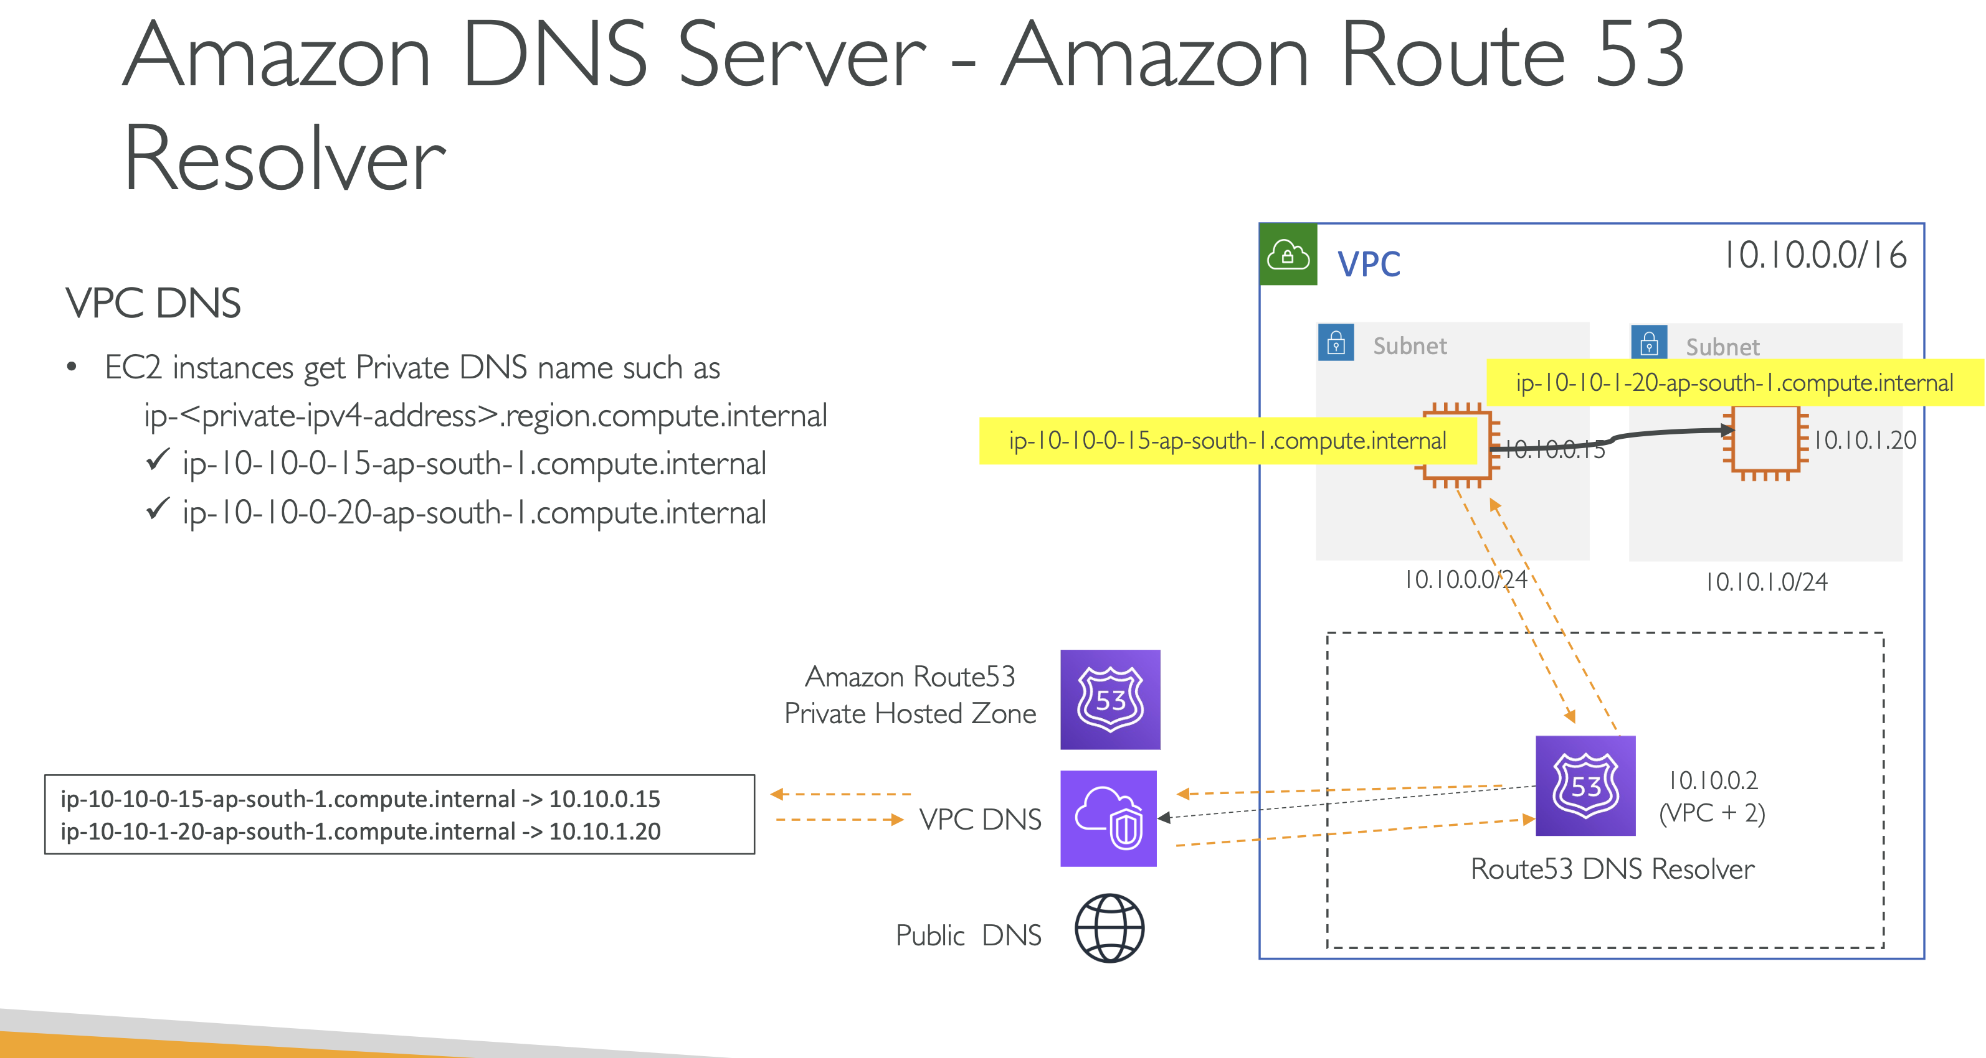

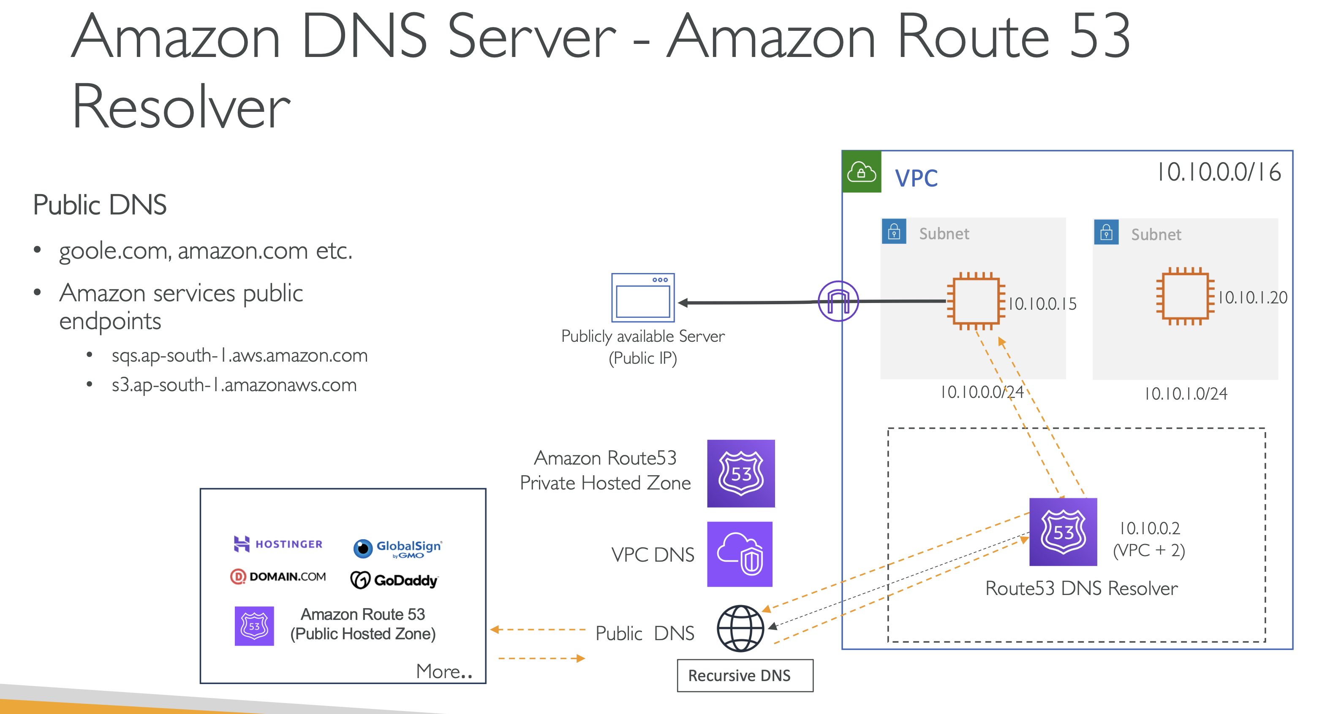

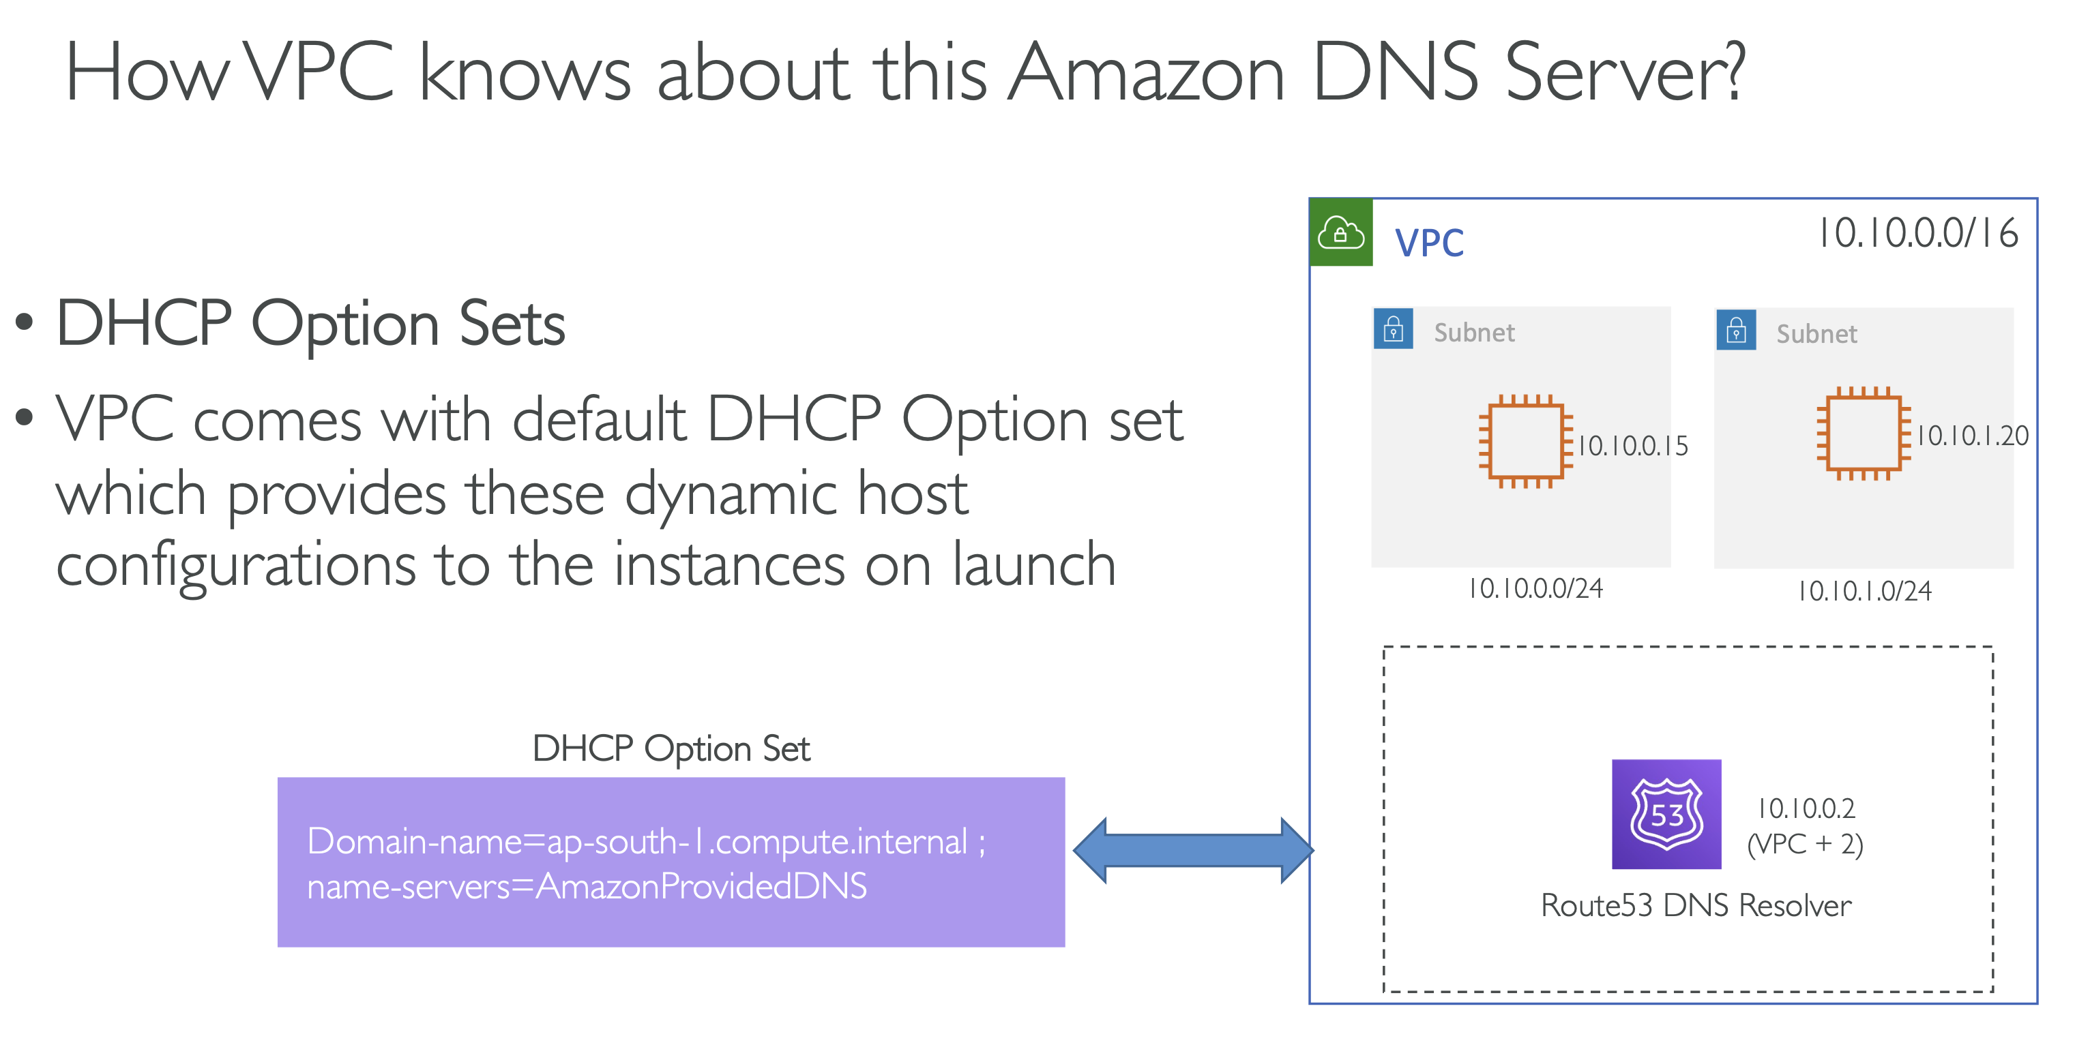

**DHCP (Dynamic Host Configuration Protocol)** is a service that **automatically gives devices an IP address and network settings** so they can communicate on a network.

👉 In simple terms: **DHCP saves you from manually configuring IP addresses.**

**What it does (exactly):**

* Assigns an **IP address**
* Provides **subnet mask**
* Gives **default gateway**
* Provides **DNS server details**

**One-line summary:**  
**DHCP automatically sets up network details for devices when they join a network.**

Now, one thing to note here is that you cannot modify the existing DHCP option set, but rather you would have to create a new DHCP option set and then associate that with your existing VPC.

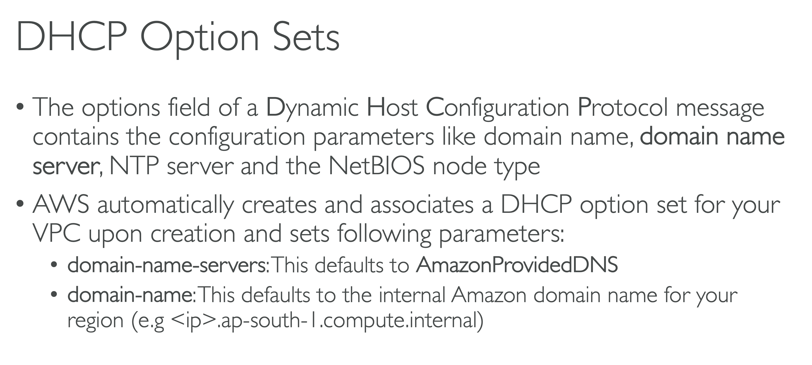

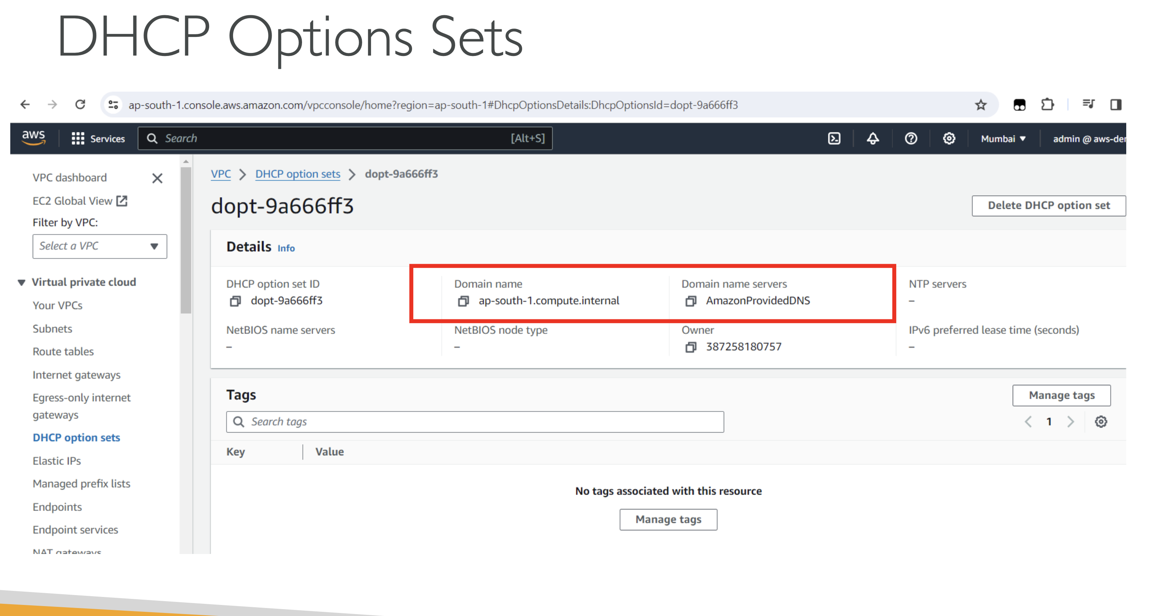

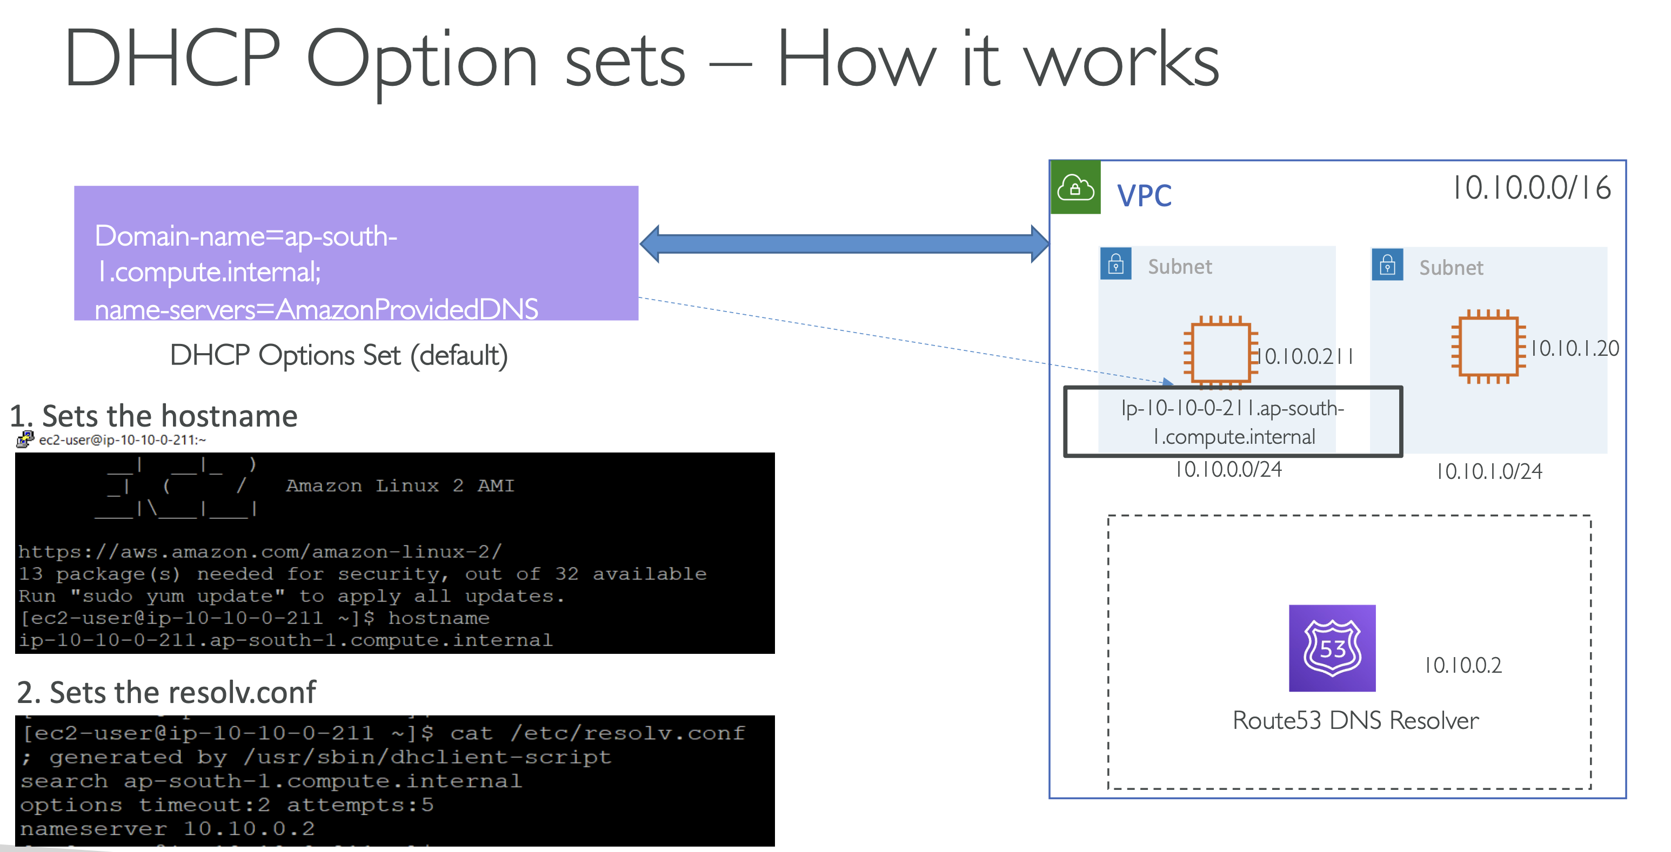

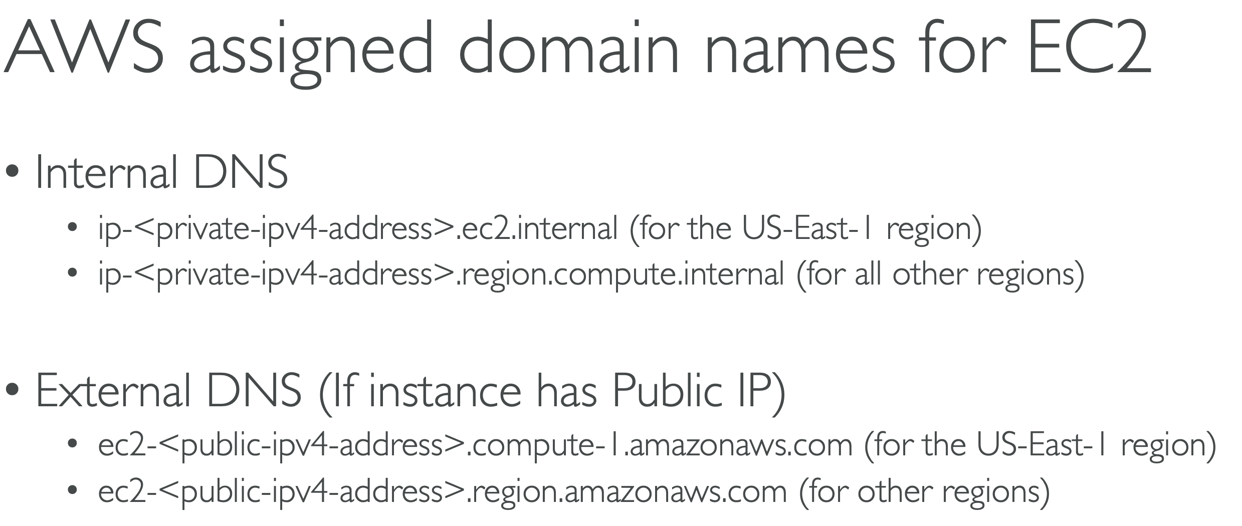

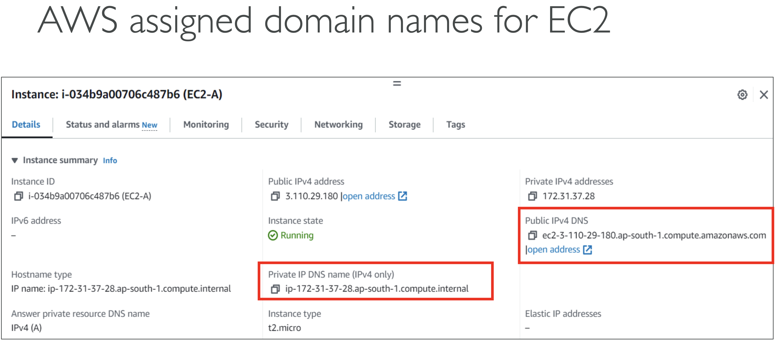

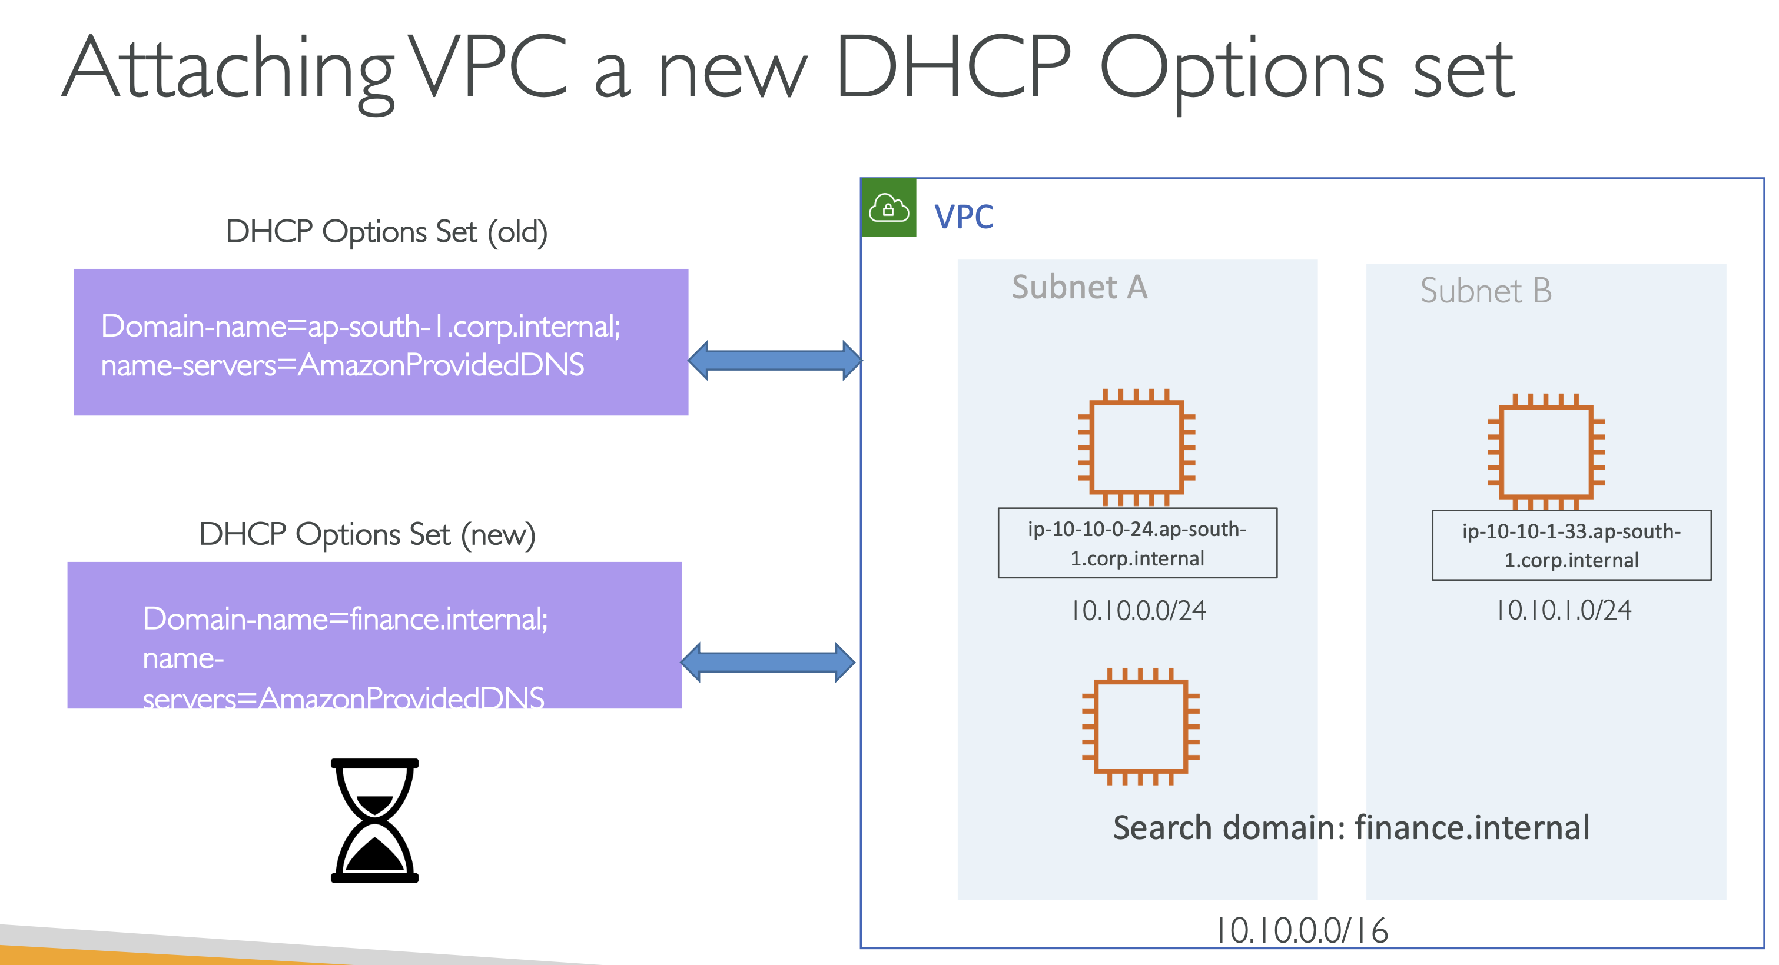

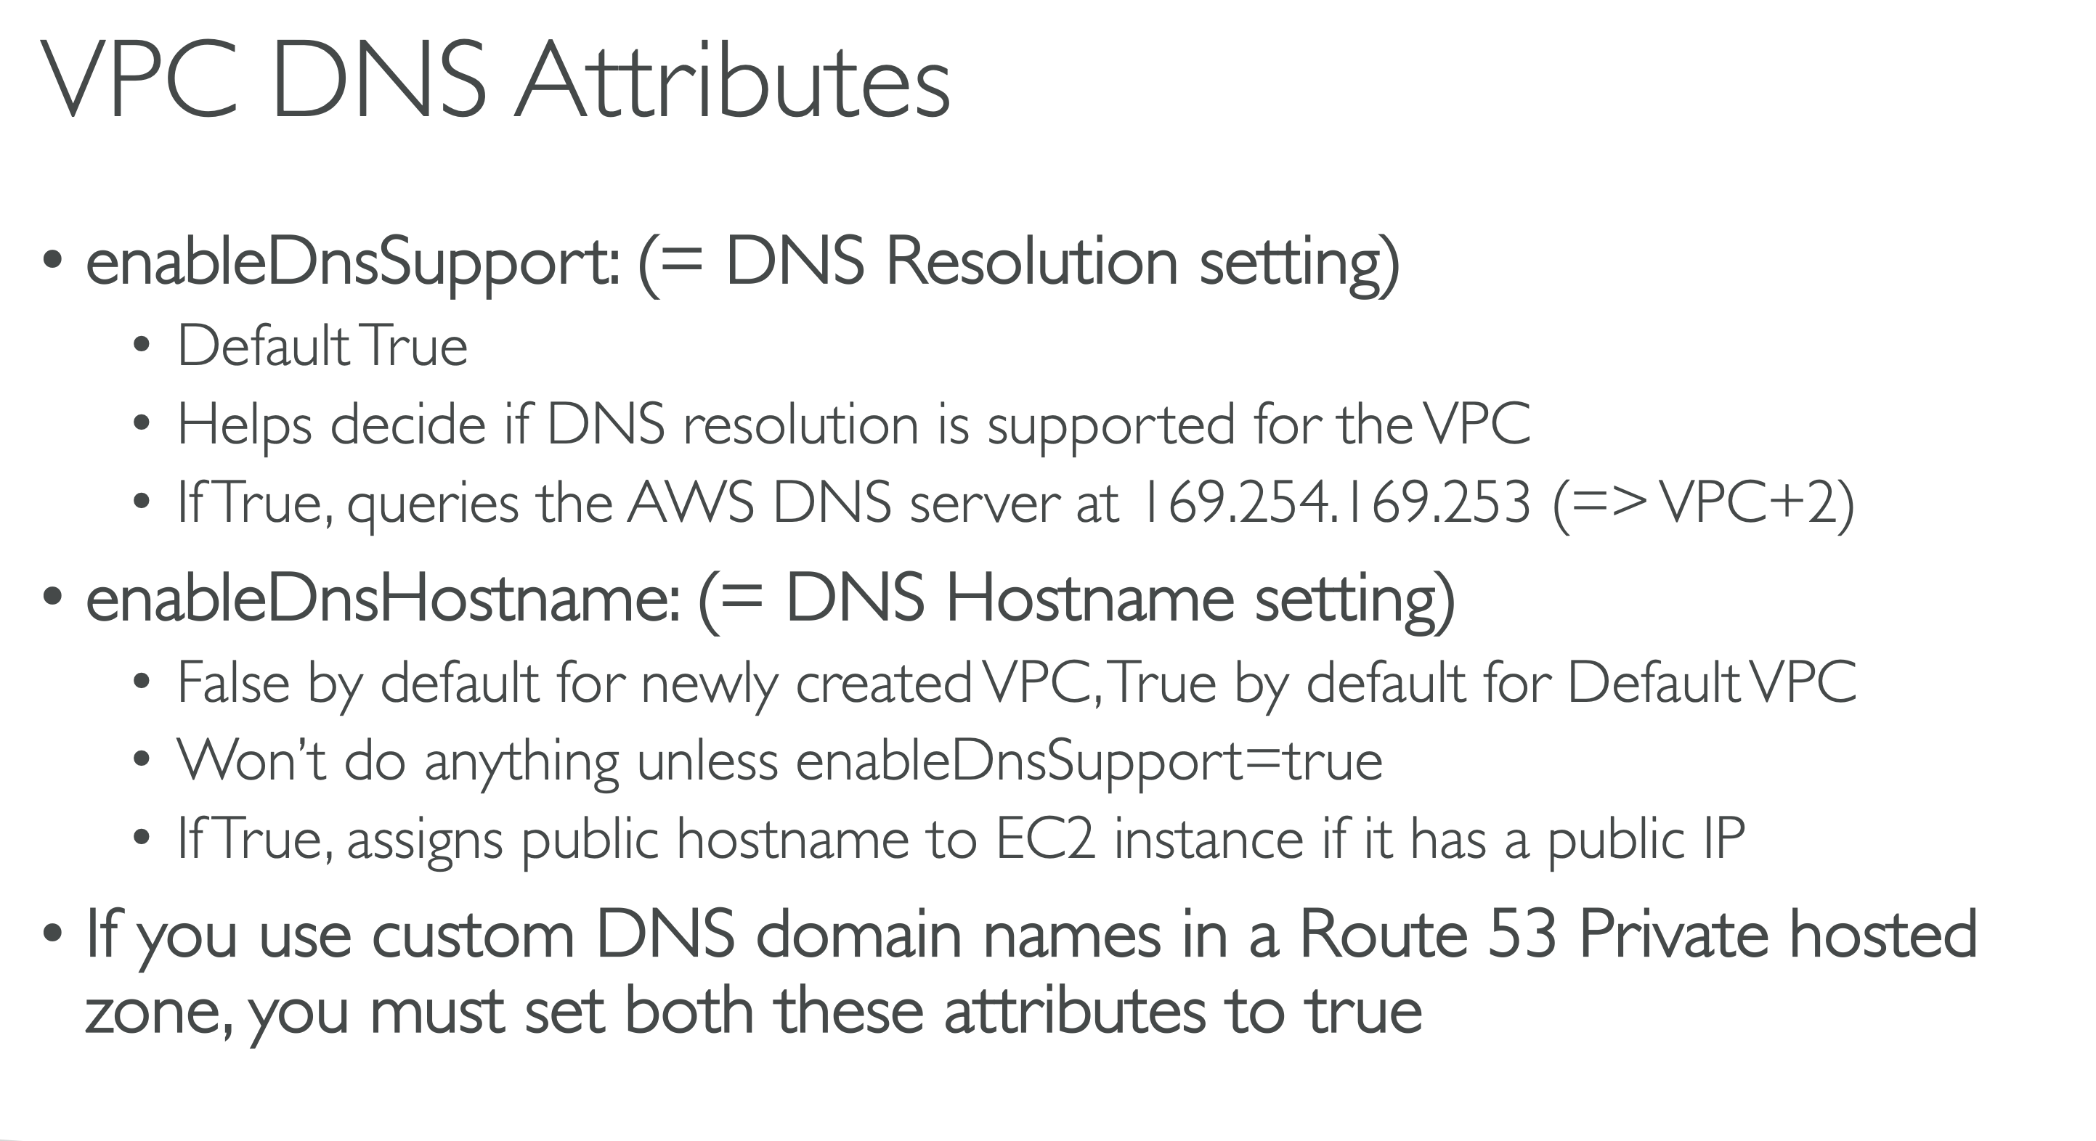

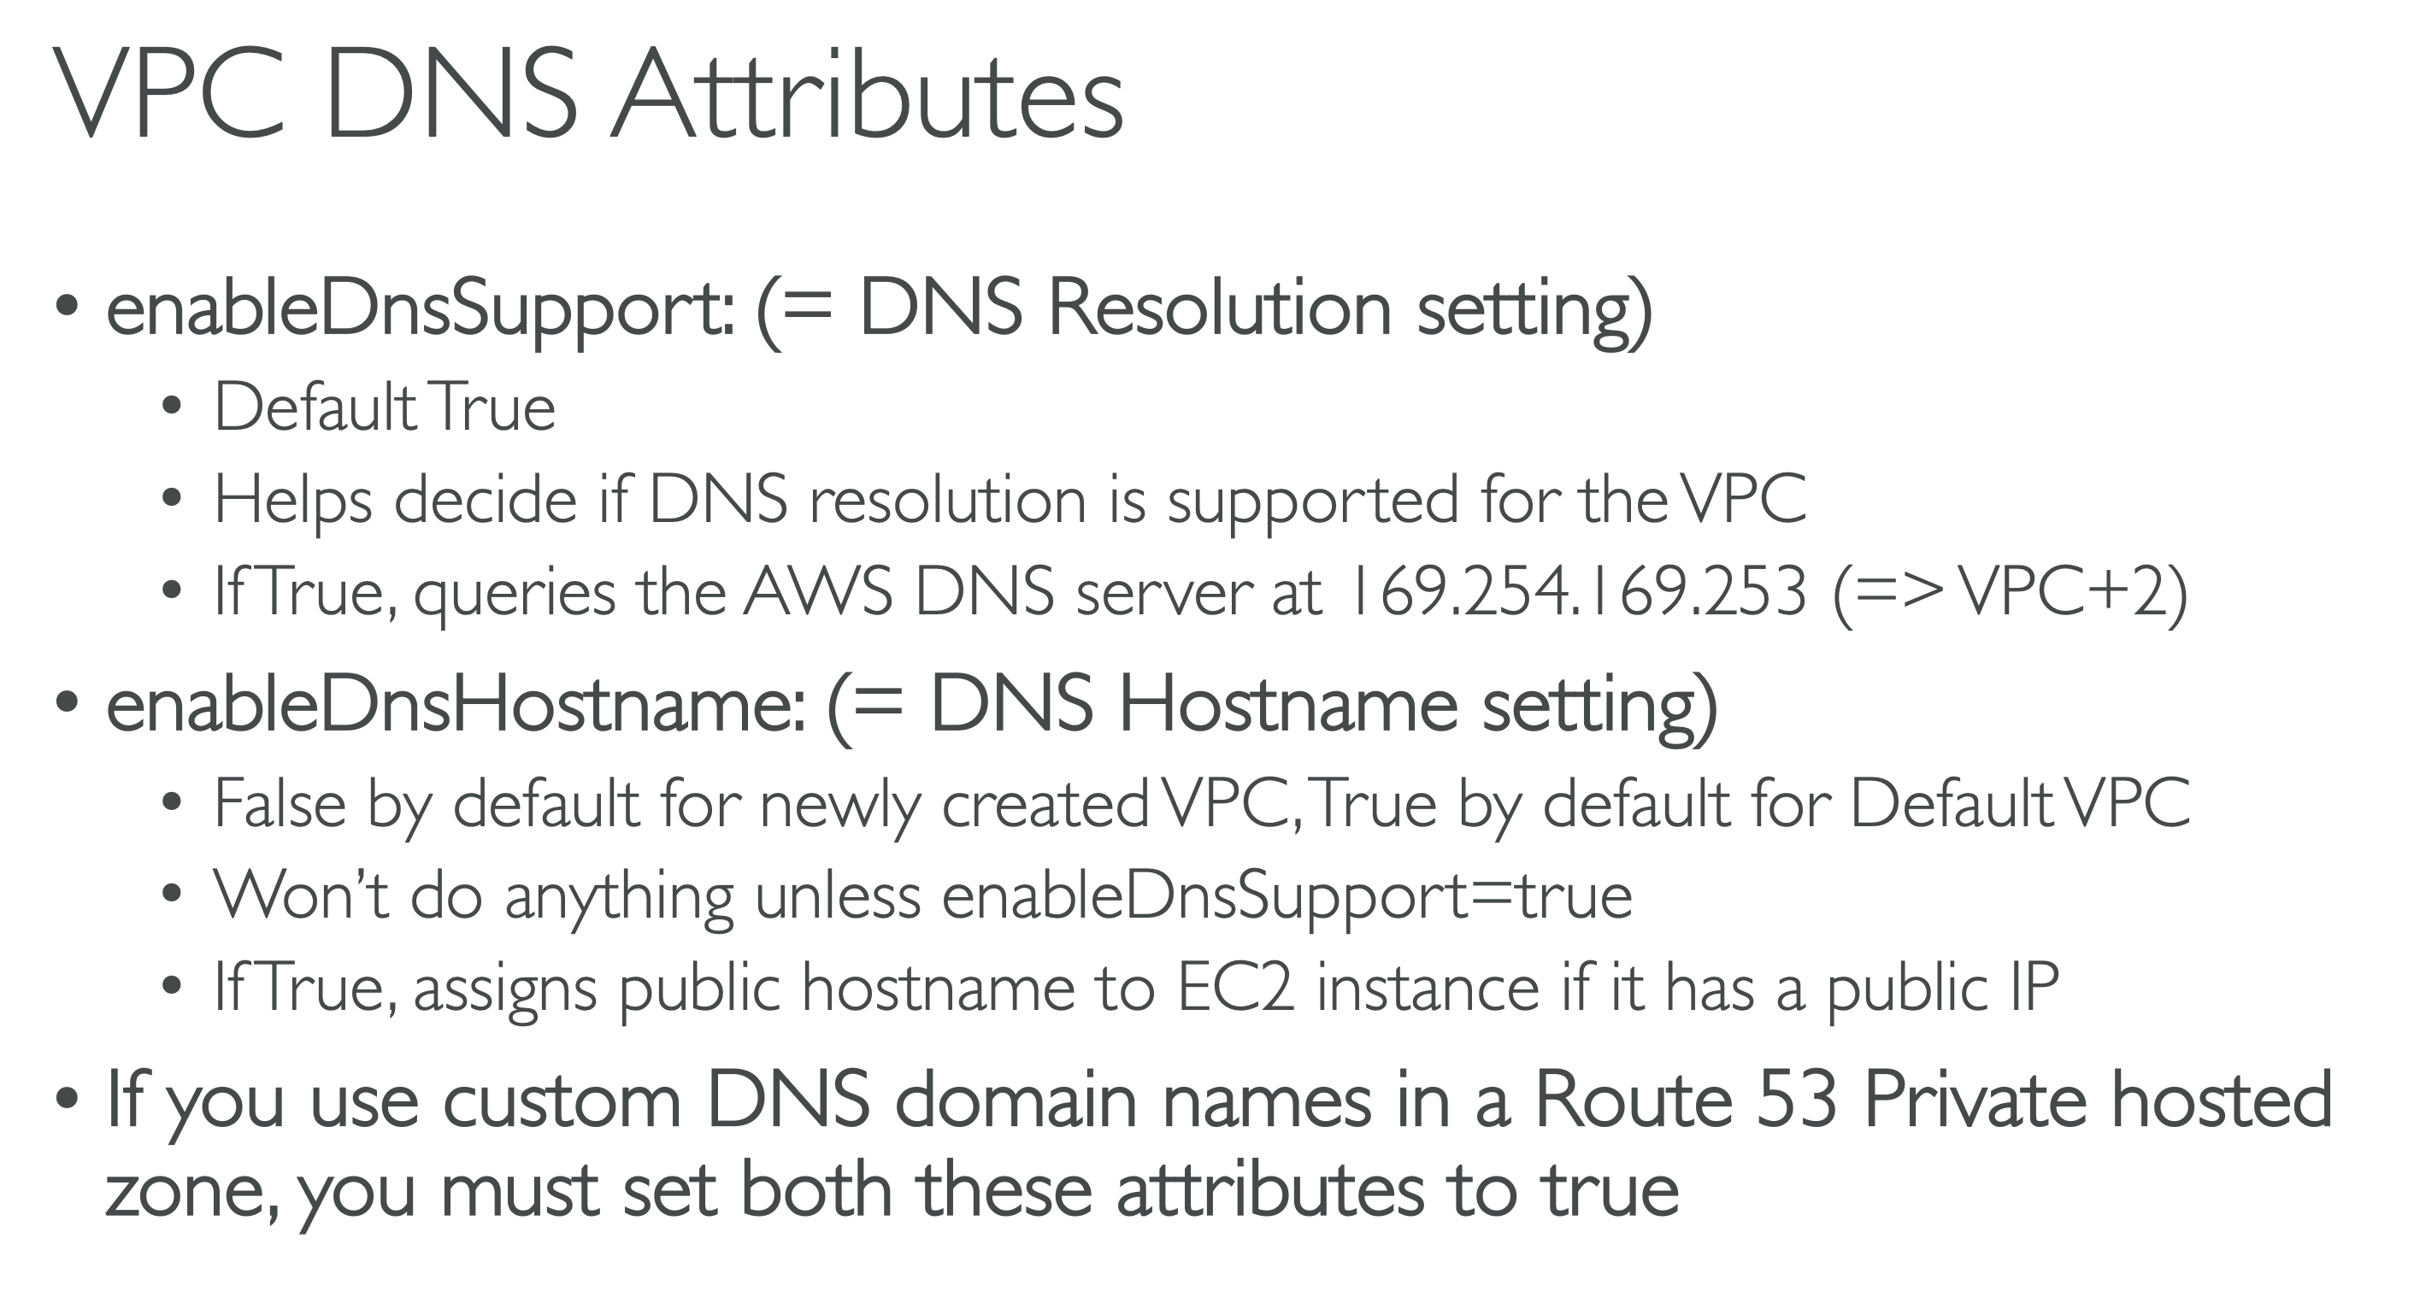

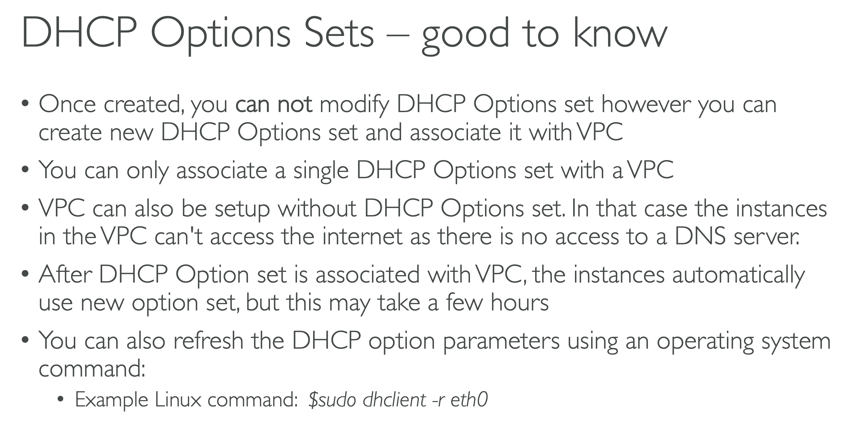

Route 53 DNS Resolver Endpoints:-

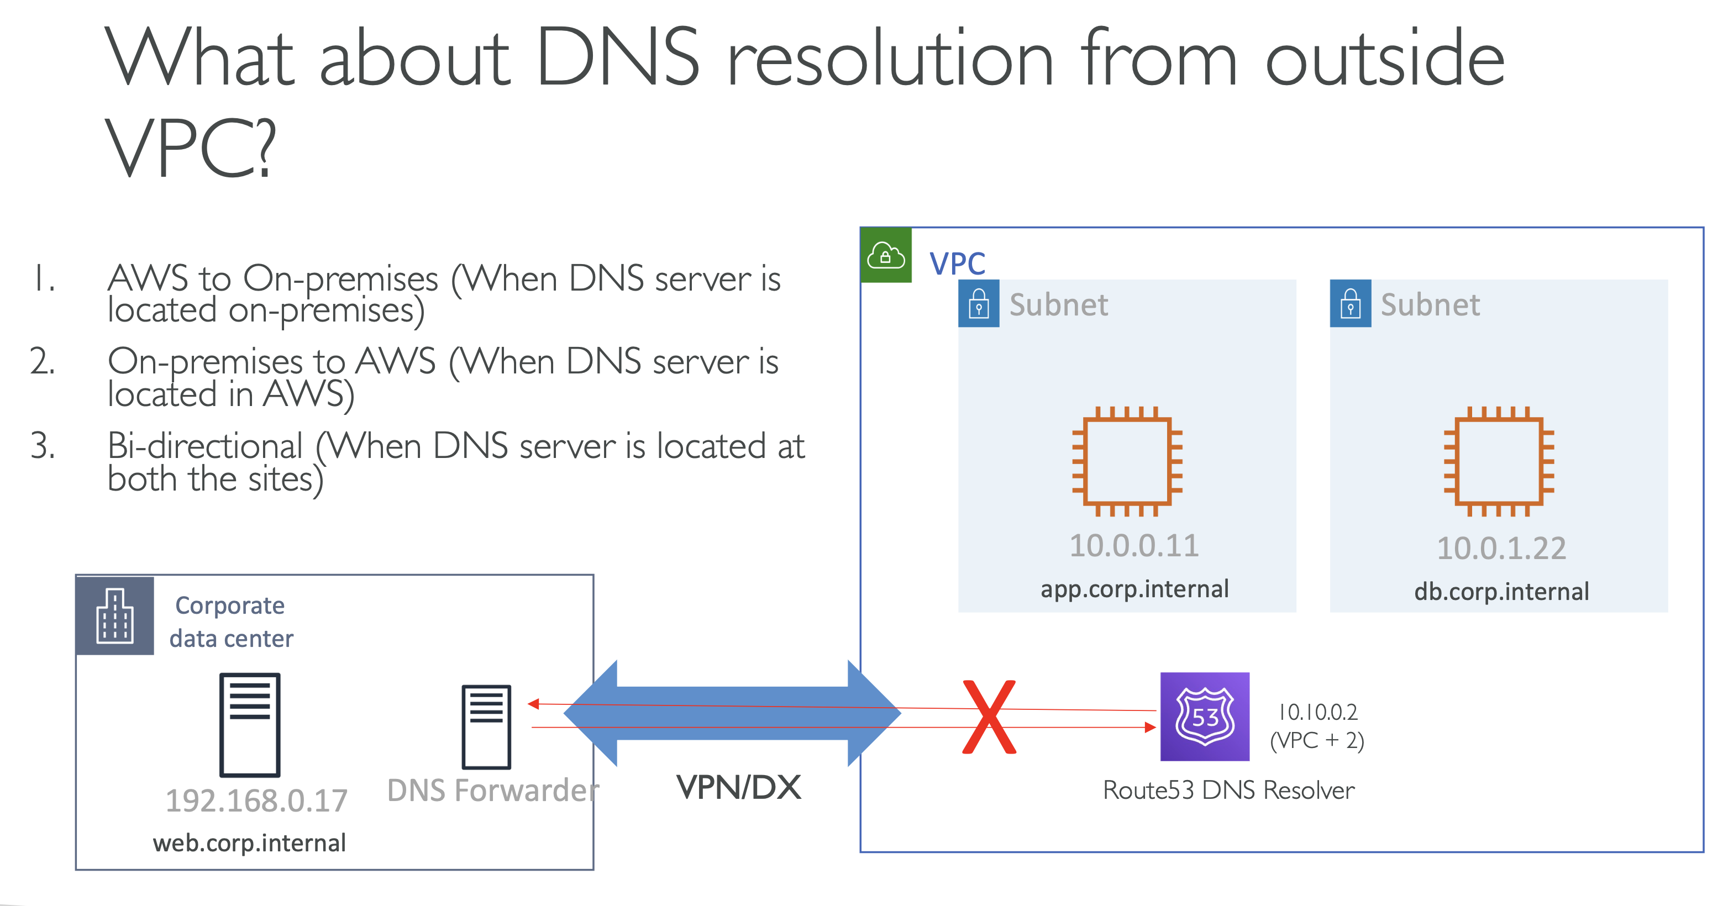

Now, if that is the case, you might be assuming that if both these networks are connected over a VPN or a direct connect, then very well this DNS server can reach to your route 53 DNS resolver and then everything will work. But that's not the case. By default, this route 53 DNS server is not accessible from your on premises network and that was the problem and exactly to solve this problem, AWS launched route 53 DNS resolver endpoints.

